DAY 26_Strings & Tuples
Challenge 1: Find Longest Student Name
Find the longest name from tuple.
Input
students = ("Anu", "Ravikumar", "Jo")
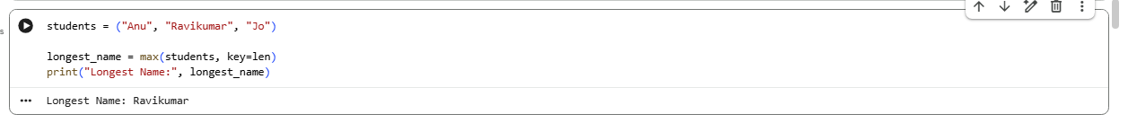
Challenge 2: Join Subjects into Single String
Display subjects in UI
Input
subjects = ("Math", "Science", "English")
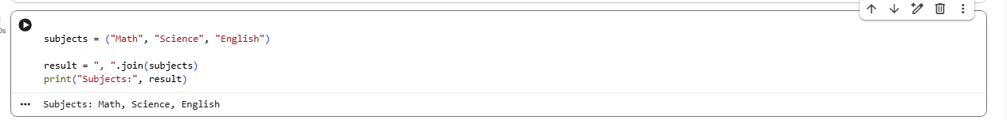
Challenge 3: Reverse Each Student Name
Data masking requirement
Input
students = ("Anu", "Ravi")
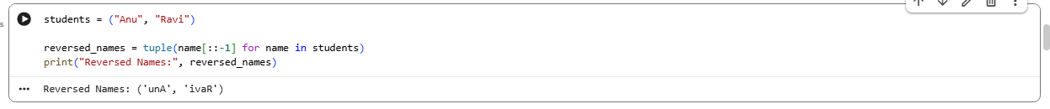
Challenge 4: Count Vowels in Each Name
Analyze student names
Input
students = ("Anu", "Ravi")
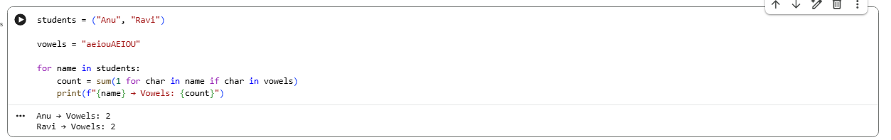
Challenge 5: Convert Tuple to Uppercase String
Prepare report header
Input
courses = ("python", "sql", "power bi")

